23.76: a) At 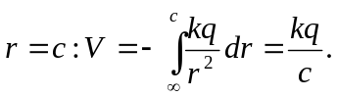
b) At 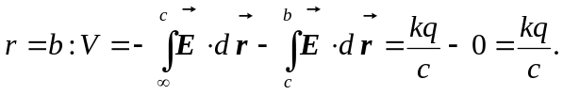
c) At 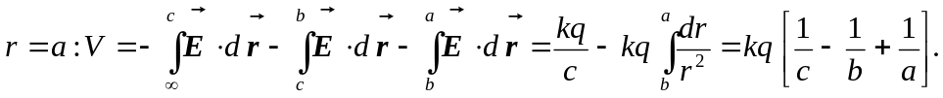
d) At 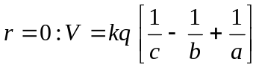 since it is inside a metal sphere, and thus at the same potential as its surface.

